**Abstract**

Building energy simulation provides insights into building performance and retrofit opportunities. Various challenges exist in the modeling process, including the highly uncertain building parameters. With the increasing availability of sensors and meters in buildings, it’s easy and cost-effective to measure building indoor environmental parameters, such as dry-bulb temperature, humidity ratio, and CO2 concentration. This paper develops a set of physics-based inverse algorithms which can solve the highly uncertain and hard-to-measure building parameters such as zone people count and air infiltration rate. Three simulation-based case studies are conducted to validate the inverse algorithms with measured zone air, zone humidity ratio, and zone CO2 concentration, respectively. The developed approach can accurately solve the zone people count and air infiltration with sub-hourly resolution.

1. **Introduction**

Inverse modeling literatures.

1. **Methodologies**
   1. **The zone balance equations**

The physics-based zone heat, moisture, and contaminant equations (forward equations) [EnergyPlus Engineering Reference] serve as the basis of the inverse modeling algorithms. The forward balance equations take into account of the effect of internal gains (e.g., lighting system, electrical equipment, people, etc.), heat/mass exchanges with surfaces, connected zone air, outdoor air via infiltration, as well as HVAC system supply air. The relationship between zone air sensible heat change and heat transfers from various sources can be expressed as the following:

$$C_{z}\frac{dT_{z}}{dt}=\sum_{i=1}^{N_{sl}}{{\dot{Q}}_{i}}+\sum_{i=1}^{N_{surfaces}}{h_{i}}A_{i}\left(T_{si}-T_{z}\right)+\sum_{i=1}^{N_{zones}}{{\dot{m}}_{i}}C_{p}\left(T_{zi}-T_{z}\right)+{\dot{m}}_{inf}C_{p}\left(T_{∞}-T_{z}\right)+{\dot{Q}}_{sys}$$

(1)

Where $C_{z}$ is the zone air total sensible heat capacity, $\sum_{i=1}^{N_{sl}}{{\dot{Q}}_{i}}$ is the sum of convective internal heat gains, $\sum_{i=1}^{N_{surfaces}}{h_{i}}A_{i}\left(T_{si}-T_{z}\right)$ is sum of convective heat gains from internal surfaces, ${\dot{m}}_{inf}C_{p}\left(T_{∞}-T_{z}\right)$ is the convective heat gain from outdoor air infiltration, and ${\dot{Q}}_{sys}$ is the convective heat transfer from the HVAC systems.

Similarly, the zone moisture balance equation can be expressed as:

$$C_{w}\frac{dW_{z}}{dt}=\sum_{i=1}^{N_{sl}}{m_{i}}+\sum_{i=1}^{N_{surfaces}}{A_{i}h_{mi}ρ_{air}}\left(W_{si}-W_{z}\right)+\sum_{i=1}^{N_{zones}}{{\dot{m}}_{i}}\left(W_{zi}-W_{z}\right)+{\dot{m}}_{inf}\left(W_{∞}-W_{z}\right)+{\dot{m}}_{sys}\left(W_{sup}-W_{z}\right)$$

(2)

Where $C_{w}$ is the zone air moisture capacity, $\sum_{i=1}^{N_{sl}}{m_{i}}$ is the sum of internal moisture gains, $\sum_{i=1}^{N_{surfaces}}{A_{i}h_{mi}ρ_{air}}\left(W_{si}-W_{z}\right)$ is the sum of convective moisture gains from the internal surfaces, $\sum_{i=1}^{N_{zones}}{{\dot{m}}_{i}}\left(W_{zi}-W_{z}\right)$ is the sum of convective moisture gains from the connected zones, ${\dot{m}}_{inf}\left(W_{∞}-W_{z}\right)$ is the convective moisture gain from outdoor air infiltration, and ${\dot{m}}_{sys}\left(W_{sup}-W_{z}\right)$ is the convective moisture gain from the HVAC systems.

And the zone CO2 balance equation can be expressed as:

$$C_{{CO}_{2}}\frac{dC_{z}}{dt}=\sum_{i=1}^{N_{sl}}{m_{i}}+\sum_{i=1}^{N_{zones}}{{\dot{m}}_{i}}\left(C_{zi}-C_{z}\right)+{\dot{m}}_{inf}\left(C_{∞}-C_{z}\right)+{\dot{m}}_{sys}\left(C_{sup}-C_{z}\right)$$

(3)

Where $C_{{CO}_{2}}$ is the zone air CO2 capacity, is the sum of internal CO2 gains, is the CO2 gains from connected zones, is the CO2 gains from outdoor air infiltration, and ${\dot{m}}_{sys}\left(C_{sup}-C_{z}\right)$ is the CO2 gains from the HVAC systems.

* 1. **The inverse modeling algorithms**

The inverse modeling algorithms are developed to solve the zone air system balance equations in their ordinary differential format. In this study, EnergyPlus is used as the simulation engine. But the methodologies can be applied in other physics-based simulation engines. Depending on the model assumptions and available measured zone parameters, the inverse modeling algorithms can be used to solve different unknown parameters such as people count, air infiltration rate, zone internal thermal mass, and HVAC supply airflow rate. [Importance of people count and air infiltration]. Thus, this study implemented the inverse algorithms in EnergyPlus to solve people count and air infiltration rate.

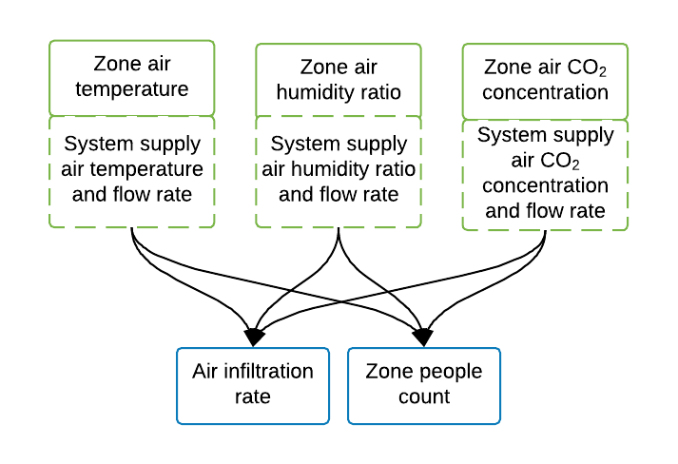  
**Figure 1**. Relationship between measured parameters and inversely solvable unknown parameters

The ordinary differential equations (1), (2), and (3) can be solved with finite difference approach which requires time-series measurements of zone air temperature, humidity ratio, or CO2 concentration. With the smart sensor network, the measurements are easily accessible in modern buildings. EnergyPlus uses third-order backward approximation to solve dry-bulb temperature, humidity ratio, or CO2 concertation with the balance equations (1), (2), and (3) in its zone predictor-corrector solution. It was proved to provide sufficient accuracy. [EnergyPlus validation]. Therefore, the proposed inverse algorithms also adopt the third-order backward approximation approach. With the third-order backward approximation, equations (1), (2), and (3) and be re-written as (4), (5), and (6) below, respectively:

$$C_{z}\frac{\frac{11}{6}T_{z}^{t}-3T_{z}^{t-δt}+\frac{3}{2}T_{z}^{t-2δt}-\frac{1}{3}T_{z}^{t-3δt}}{δt}=\sum_{i=1}^{N_{sl}}{{\dot{Q}}_{i}}+\sum_{i=1}^{N_{surfaces}}{h_{i}}A_{i}\left(T_{si}^{t}-T_{z}^{t}\right)+\sum_{i=1}^{N_{zones}}{{\dot{m}}_{i}}C_{p}\left(T_{zi}^{t}-T_{z}^{t}\right)+{\dot{m}}_{inf}C_{p}\left(T_{∞}^{t}-T_{z}^{t}\right)+{\dot{m}}_{sys}C_{p}\left(T_{sup}^{t}-T_{z}^{t}\right)$$

(4)

$$C_{wz}\frac{\frac{11}{6}W_{z}^{t}-3W_{z}^{t-δt}+\frac{3}{2}W_{z}^{t-2δt}-\frac{1}{3}W_{z}^{t-3δt}}{δt}=\sum_{i=1}^{N_{sl}}{m_{i}}+\sum_{i=1}^{N_{surfaces}}{A_{i}h_{mi}ρ_{air}}\left(W_{si}^{t}-W_{z}^{t}\right)+\sum_{i=1}^{N_{zones}}{{\dot{m}}_{i}}\left(W_{zi}^{t}-W_{z}^{t}\right)+{\dot{m}}_{inf}\left(W_{∞}^{t}-W_{z}^{t}\right)+{\dot{m}}_{sys}\left(W_{sup}^{t}-W_{z}^{t}\right)$$

(5)

$$C_{{CO}_{2}}\frac{\frac{11}{6}C_{z}^{t}-3C_{z}^{t-δt}+\frac{3}{2}C_{z}^{t-2δt}-\frac{1}{3}C_{z}^{t-3δt}}{δt}=\sum_{i=1}^{N_{sl}}{m_{i}}+\sum_{i=1}^{N_{zones}}{{\dot{m}}_{i}}\left(C_{zi}^{t}-C_{z}^{t}\right)+{\dot{m}}_{inf}\left(C_{∞}^{t}-C_{z}^{t}\right)+{\dot{m}}_{sys}\left(C_{sup}^{t}-C_{z}^{t}\right)$$

(6)

The superscript notations of $T_{z}$, $W_{z}$, and $C_{z}$ represent the timestamp of the measurements. For example, $T_{z}^{t}$ is the measured zone air dry-bulb temperature at current timestamp, while $T_{z}^{t-δt}$ is the measured dry-bulb air temperature at one time step earlier than the current timestamp.

The inverse modeling algorithms are based on the following assumptions (the exact assumption varies depending on which parameter is used as input):

1. The zone air sensible thermal mass, total humidity capacity, or total CO2 concentration capacity is known and fixed.
2. If the system supply air temperature, humidity ratio, or CO2 concentration is not measured, the building should be in free-floating (HVAC off) mode.
3. The zone internal sensible heat gain, moisture gain, or CO2 gain is accurately modeled.
4. The inter-zone air exchange is accurately modeled.
5. The convective heat, moisture, or CO2 transfer between zone surfaces and zone air is accurately modeled.
6. The sensible heat generation rate, moisture and CO2 dissipation rate of a single person is known.

**2.2.1 Inverse modeling algorithms to solve air infiltration**

With measured zone air parameters, the air infiltration mass flow rate ${\dot{m}}_{inf}$ can be solved with equation (7), (8), or (9) shown below. For example, equation (7) calculates the sensible heat gain (or loss) rate from air infiltration with the zone sensible heat balance equation, and then solves the infiltration mass flow rate with the infiltration heat capacity and outdoor-indoor air temperature difference. If the HVAC is on during the measurements, the system supply air mass flow rate and supply air temperature also need to be measured.

$${\dot{m}}_{inf}=\frac{C_{z}\frac{\frac{11}{6}T_{z}^{t}-3T_{z}^{t-δt}+\frac{3}{2}T_{z}^{t-2δt}-\frac{1}{3}T_{z}^{t-3δt}}{δt}-[\sum_{i=1}^{N_{sl}}{{\dot{Q}}_{i}}+\sum_{i=1}^{N_{surfaces}}{h_{i}}A_{i}\left(T_{si}^{t}-T_{z}^{t}\right)+\sum_{i=1}^{N_{zones}}{{\dot{m}}_{i}}C_{p}\left(T_{zi}^{t}-T_{z}^{t}\right)+{\dot{m}}_{sys}C_{p}\left(T_{sup}^{t}-T_{z}^{t}\right)]}{C_{p}\left(T_{∞}^{t}-T_{z}^{t}\right)}$$

(7)

$${\dot{m}}_{inf}=\frac{C_{wz}\frac{\frac{11}{6}W_{z}^{t}-3W_{z}^{t-δt}+\frac{3}{2}W_{z}^{t-2δt}-\frac{1}{3}W_{z}^{t-3δt}}{δt}-[\sum_{i=1}^{N_{sl}}{m_{i}}+\sum_{i=1}^{N_{surfaces}}{A_{i}h_{mi}ρ_{air}}\left(W_{si}^{t}-W_{z}^{t}\right)+\sum_{i=1}^{N_{zones}}{{\dot{m}}_{i}}\left(W_{zi}^{t}-W_{z}^{t}\right)+{\dot{m}}_{sys}\left(W_{sup}^{t}-W_{z}^{t}\right)]}{W_{∞}^{t}-W_{z}^{t}}$$

(8)

$${\dot{m}}_{inf}=\frac{C_{{CO}_{2}}\frac{\frac{11}{6}C_{z}^{t}-3C_{z}^{t-δt}+\frac{3}{2}C_{z}^{t-2δt}-\frac{1}{3}C_{z}^{t-3δt}}{δt}-[\sum_{i=1}^{N_{sl}}{m_{i}}+\sum_{i=1}^{N_{zones}}{{\dot{m}}_{i}}\left(C_{zi}^{t}-C_{z}^{t}\right)+{\dot{m}}_{sys}\left(C_{sup}^{t}-C_{z}^{t}\right)]}{C_{∞}^{t}-C_{z}^{t}}$$

(9)

**2.2.2 Inverse modeling algorithms to solve people count**

With measured zone air parameters, the zone people count $N_{occ}$ can be solved with the following pairs of equations. For instance, equation (10) solves the zone total internal heat gain rate. Then, equation (11) solves the number of occupant in the zone by dividing the total sensible heat gain rate from people to the sensible heat generation rate of a single person. Similar to the algorithms solving air infiltration rate, the system supply air mass flow rate and supply air temperature also need to be measured if the HVAC system is on. Equation (12) and (13) solve the people count with measured humidity ratio. Equation (14) and (15) solve the people count with measured CO2 concentration.

$$\sum_{i=1}^{N_{sl}}{{\dot{Q}}_{i}}=C_{z}\frac{\frac{11}{6}T_{z}^{t}-3T_{z}^{t-δt}+\frac{3}{2}T_{z}^{t-2δt}-\frac{1}{3}T_{z}^{t-3δt}}{δt}-[\sum_{i=1}^{N_{surfaces}}{h_{i}}A_{i}\left(T_{si}^{t}-T_{z}^{t}\right)+\sum_{i=1}^{N_{zones}}{{\dot{m}}_{i}}C_{p}\left(T_{zi}^{t}-T_{z}^{t}\right)+{\dot{m}}_{sys}C_{p}\left(T_{sup}^{t}-T_{z}^{t}\right)]$$

(10)

(11)

(12)

(13)

(14)

(15)

* 1. **Convergence**

There can be many factors affecting the convergence when trying to solve the differential equation numerically with the third-order backward approximation. The most common issue is the overflow. The latest version of EnergyPlus core is written in C++. Just as any other language, it overflows when the result from an operation exceed a certain range. For the inverse modeling algorithm, overflow can happen when calculating the air infiltration rate. For instance, the indoor-outdoor air temperature difference term $\left(T_{∞}^{t}-T_{z}^{t}\right)$ can be a very small number when the two temperatures are very close. Overflow will happen if the program tries to calculate the air infiltration rate by dividing the denominator of equation (7) by $C_{p}\left(T_{∞}^{t}-T_{z}^{t}\right)$. Therefore, conditions checks are needed when implementing the algorithm in the code. In this case, a threshold of 0.05 °C or greater temperature difference must be met to calculate the infiltration rate at one timestamp. Similarly, thresholds are added for the algorithms using humidity ratio and CO2 concentration.

In addition, EnergyPlus uses a zone predictor-corrector mechanism to calculate the heating or cooling needs of a zone on HVAC system, and update the zone air parameters based on the calculated amount of heating or cooling the HVAC system provides to a zone. The uncertainties such as truncation errors in those predictor-corrector routines can cause unrealistic in the inverse modeling routine. Therefore, thresholds for infiltration and people count calculation are applied to the code. For infiltration, a valid value must be within the range of 0 to 10 air change per hour. For people count, the lower bound is zero, and the upper-bound is the total possible internal heat/moisture/CO2 gain divided by the heat/moisture/CO2 generation rate.

1. **Case Study**

To verify and demonstrate the developed inverse modeling algorithms, a simulation-based case study was conducted. This section presents model settings, solution scenarios, and results of the case study.

* 1. **Model settings**

An EnergyPlus building model is used in the case study. The model represents a two-story building with two zones on each floor with a 1600 m2 total floor area. Three locations are considered to cover typical hot, cold, and mild climate. There are two rounds of simulations. The first round is the forward simulation, where the air infiltration rate and people count are provided as model inputs. The forward simulation is used to generate the virtual measurements of the zone air and system supply air parameters. Then in the second round of simulations the virtual measurements are provided as the inputs of the inverse modeling algorithms to solve air infiltration or people count. Since only one unknown variable can be solved at a time, the people count should be provided when solving the air infiltration, and vice versa. Table 1 shows the model setting details.

**Table 1**. Model settings of the case study

|  |  |  |  |
| --- | --- | --- | --- |
| **Model settings** | **Forward simulation** | **Inverse simulation 1: solving air infiltration** | **Inverse simulation 2: solving people count** |
| Purpose | Get the virtual measurements (i.e., zone air and system supply air parameters) | Use the virtual measurements to inversely solve air infiltration rates | Use the virtual measurements to inversely solve zone people counts |
| Building geometry | **Figure 2**. Model geometry sketch | | |
| Location | Chicago, Houston, San Francisco | | |
| Interior lighting power density | 9.69 W/m2 | | |
| Electric equipment power density | 6.78 W/m2 | | |
| HVAC type | Ideal air load system: the HVAC system can meet the space heating and cooling load as long as they are below the system capacity. | | |
| Air infiltration | Fixed schedule (ground truth) | NA | Fixed schedule |
| Occupancy density | 10 m2/person (ground truth) | 10 m2/person | NA |

In the forward simulation, air infiltration is modeled with the maximum air change rate and a schedule of the fractions of the maximum value in different hours of a day. Similarly, the zone people count is modeled with the maximum number of people and a schedule indicating the fractions of the maximum number of people in different hours. The forward simulation uses the infiltration rate schedule from DOE prototype small office building. People’s behavior and movements in real buildings are hard to predict, which affect the presence of people in building spaces. [Chen et al.] developed an agent based algorithm to simulate occupant movements using Markov-chain model. Based on the study, an application was developed [Occupancy Simulator]. In this case study, a stochastic occupant schedule generated by the application is used as the ground truth to mimic the high uncertain people movements in real buildings. Figure 3 and figure 4 shows the air infiltration and example people count schedules in a day.

|  |  |
| --- | --- |
|  |  |
| **Figure 3**. Air infiltration schedule | **Figure 4**. Occupancy schedule |

* 1. **Inverse solution scenarios**

There can be different use cases and solution scenarios with the inverse modeling algorithms depending on which measured parameters and model details are available in the inverse simulation. Thus, experiments with different level of details of measurements and model assumption are carried out in the case study.

1. The simplest use case is when the building’s HVAC system is free-floating during the zone air measurements and the HVAC is not modeled in the inverse simulation. This case is most suitable with when limited measurements and building model details are available. However, it requires the building’s HVAC system be turned off.
2. A more complex use case is when the HVAC is on during the zone air measurements but no HVAC detail is modeled in the inverse simulation. In this case, both zone air parameters and the system supply air parameters need to be measured, but no HVAC information is needed to be provided to the model. The system supply terms in the balance equations are calculated based on the measurements. However, since HVAC is not modeled in the simulation, its effects on the zones are not simulated.
3. The most complicated use case is when the HVAC is on during the zone air measurements, and HVAC details are modeled in the inverse simulation. This case requires not only the measurements, but also the detailed HVAC information for the inverse model.

Table 2 shows the required measurements and model assumptions for different use cases and solution scenarios.

**Table 2**. Inverse solution use cases and scenarios

|  |  |  |  |  |  |  |  |  |  |  |
| --- | --- | --- | --- | --- | --- | --- | --- | --- | --- | --- |
| **Use cases** | | **Case 1** | | | **Case 2** | | | **Case 3** | | |
| Scenarios | | S1 | S2 | S3 | S4 | S5 | S6 | S7 | S8 | S9 |
| HVAC status during measurement | | Off | Off | Off | On | On | On | On | On | On |
| HVAC is modeled | | No | No | No | No | No | No | Yes | Yes | Yes |
| Climate zones | | Chicago, Houston, San Francisco | | | | | | | | |
| Measured Parameter(s) | zone air temperature | x |  |  | x |  |  | x |  |  |
| zone air humidity ratio |  | x |  |  | x |  |  | x |  |
| zone air CO2 concentration |  |  | x |  |  | x |  |  | x |
| supply air temperature |  |  |  | x |  |  | x |  |  |
| supply air humidity ratio |  |  |  |  | x |  |  | x |  |
| supply air CO2 concentration |  |  |  |  |  | x |  |  | x |
| supply air mass flow rate |  |  |  | x | x | x | x | x | x |
| Note | | HVAC is off during measurements, no HVAC is modeled in the inverse simulation | | | HVAC is on during measurements, no HVAC is modeled in the inverse simulation | | | HVAC is on during measurements, HVAC is modeled in the inverse simulation | | |

* 1. **Results**

Based on the previous discussion, there are 216 combinations (2 unknown parameters x 4 zones x 3 locations x 3 measurements x 3 uses cases) in the case study. To illustrate the results, this section first presents time-series comparison examples. Then it presents the statistical metrics of the inverse solutions and summarizes the applicability for different use cases.

Time-series charts can help visually inspect the alignments between the inverse solution and the ground truth. Figure 5 through figure 7 shows the ground truth and the inverse solution of the air infiltration rate in one zone in the model for three use cases. The result from Chicago are selected since it covers hot summer and cold winter.

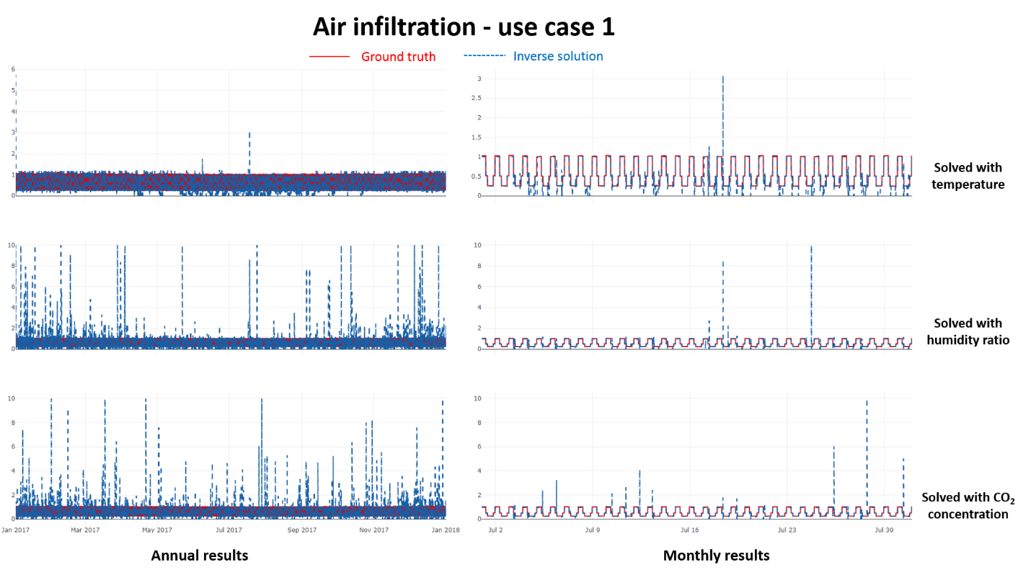

**Figure 5**. Use case 1 time-series comparison of the inverse solution and ground truth of air infiltration

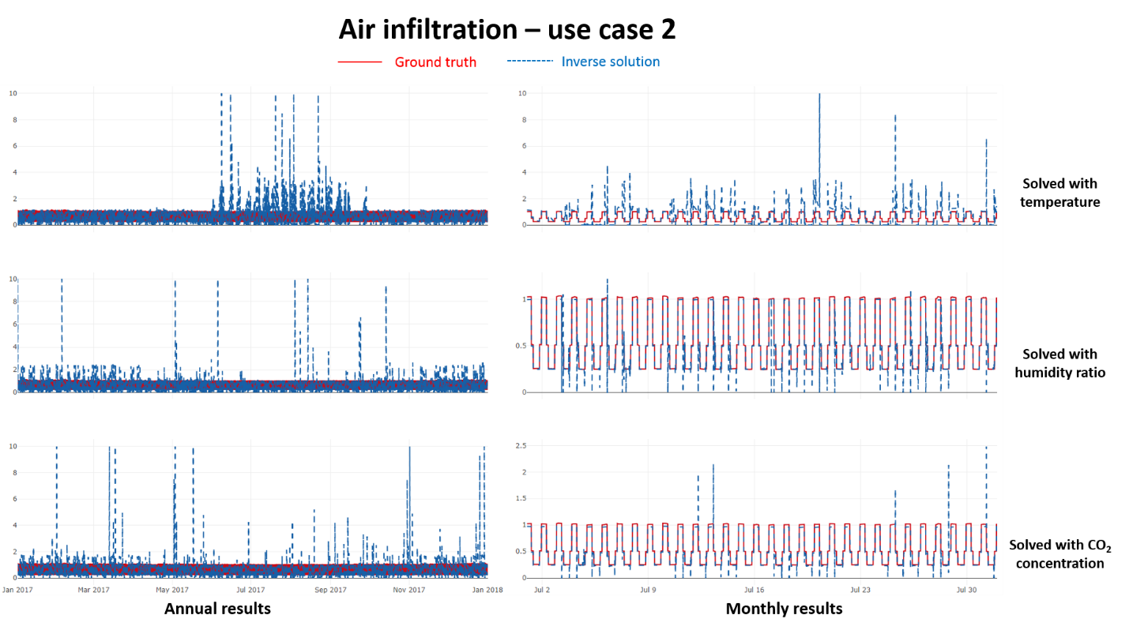

**Figure 6**. Use case 2 time-series comparison of the inverse solution and ground truth of air infiltration

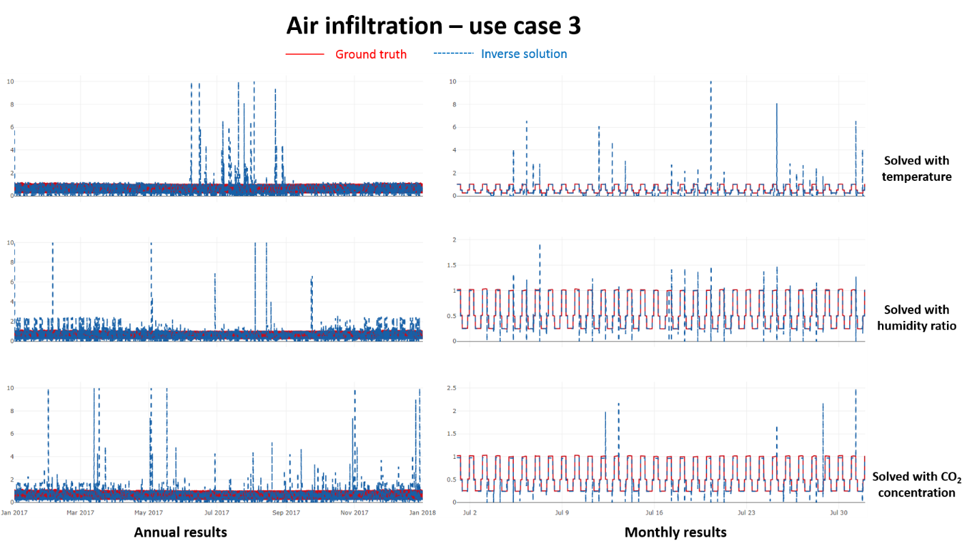

**Figure 7**. Use case 3 time-series comparison of the inverse solution and ground truth of air infiltration

As shown in the three figures above, the inverse solution of air infiltration with measured temperature, humidity ratio, and CO2 concentration have different performance for different use cases. For case 1, the solution with measured temperature has less spikes than the solution with humidity ratio and CO2 concentration.

Since there is more diversity in occupant count schedule, an annual comparison and a weekly comparison are used in the plots.

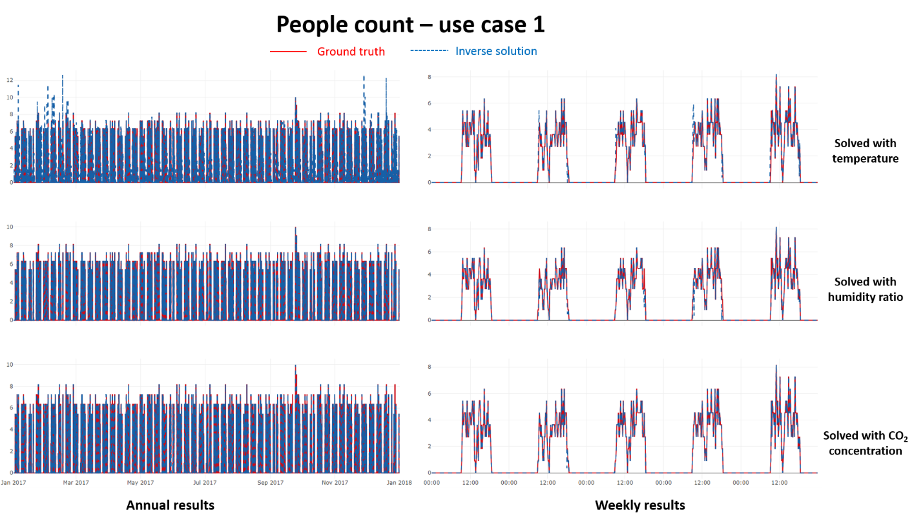

**Figure 8**. Use case 1 time-series comparison of the inverse solution and ground truth of people count

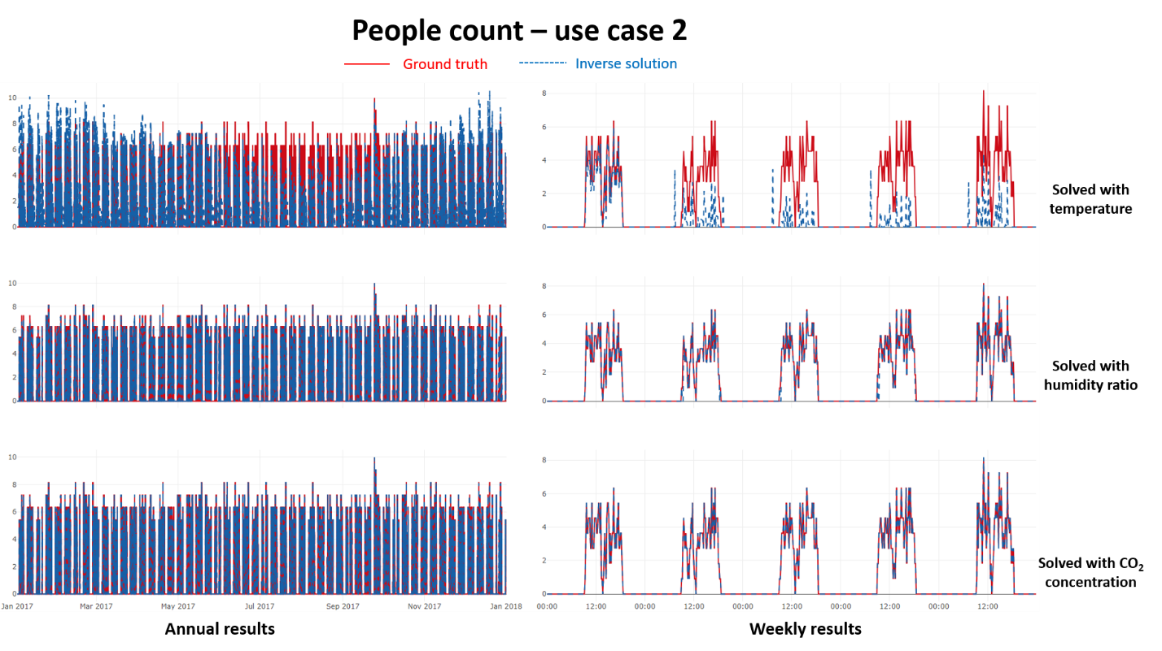

**Figure 9**. Use case 2 time-series comparison of the inverse solution and ground truth of people count

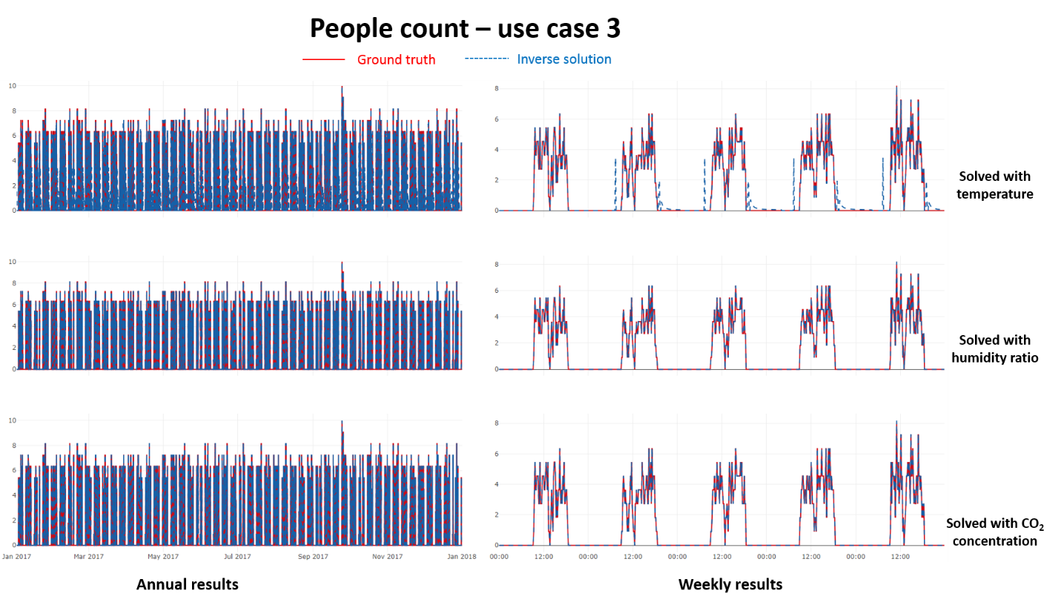

**Figure 10**. Use case 3 time-series comparison of the inverse solution and ground truth of people count

The time-series comparisons between the ground truth and the inverse solution give a snapshot of how the inverse algorithm work overall.

Comparison of the probability density between the ground truth and inverse solution can provide a statistical view of how the inverse modeling algorithms perform in solving the unknown air infiltration rate or people count. Figure x and figure show the probability densities of the ground truth and the inverse solutions of different use cases in three experimental locations for a single zone in the modeled building. In the facet plot grid, each row corresponds to one use case (see details in Table 2) and each column corresponds to a location. There are four traces in each child plot – one ground truth and three solution scenarios with the measured air temperature, measured air humidity ratio, and measured CO2 concentration, respectively. It can be seen from the figure that…

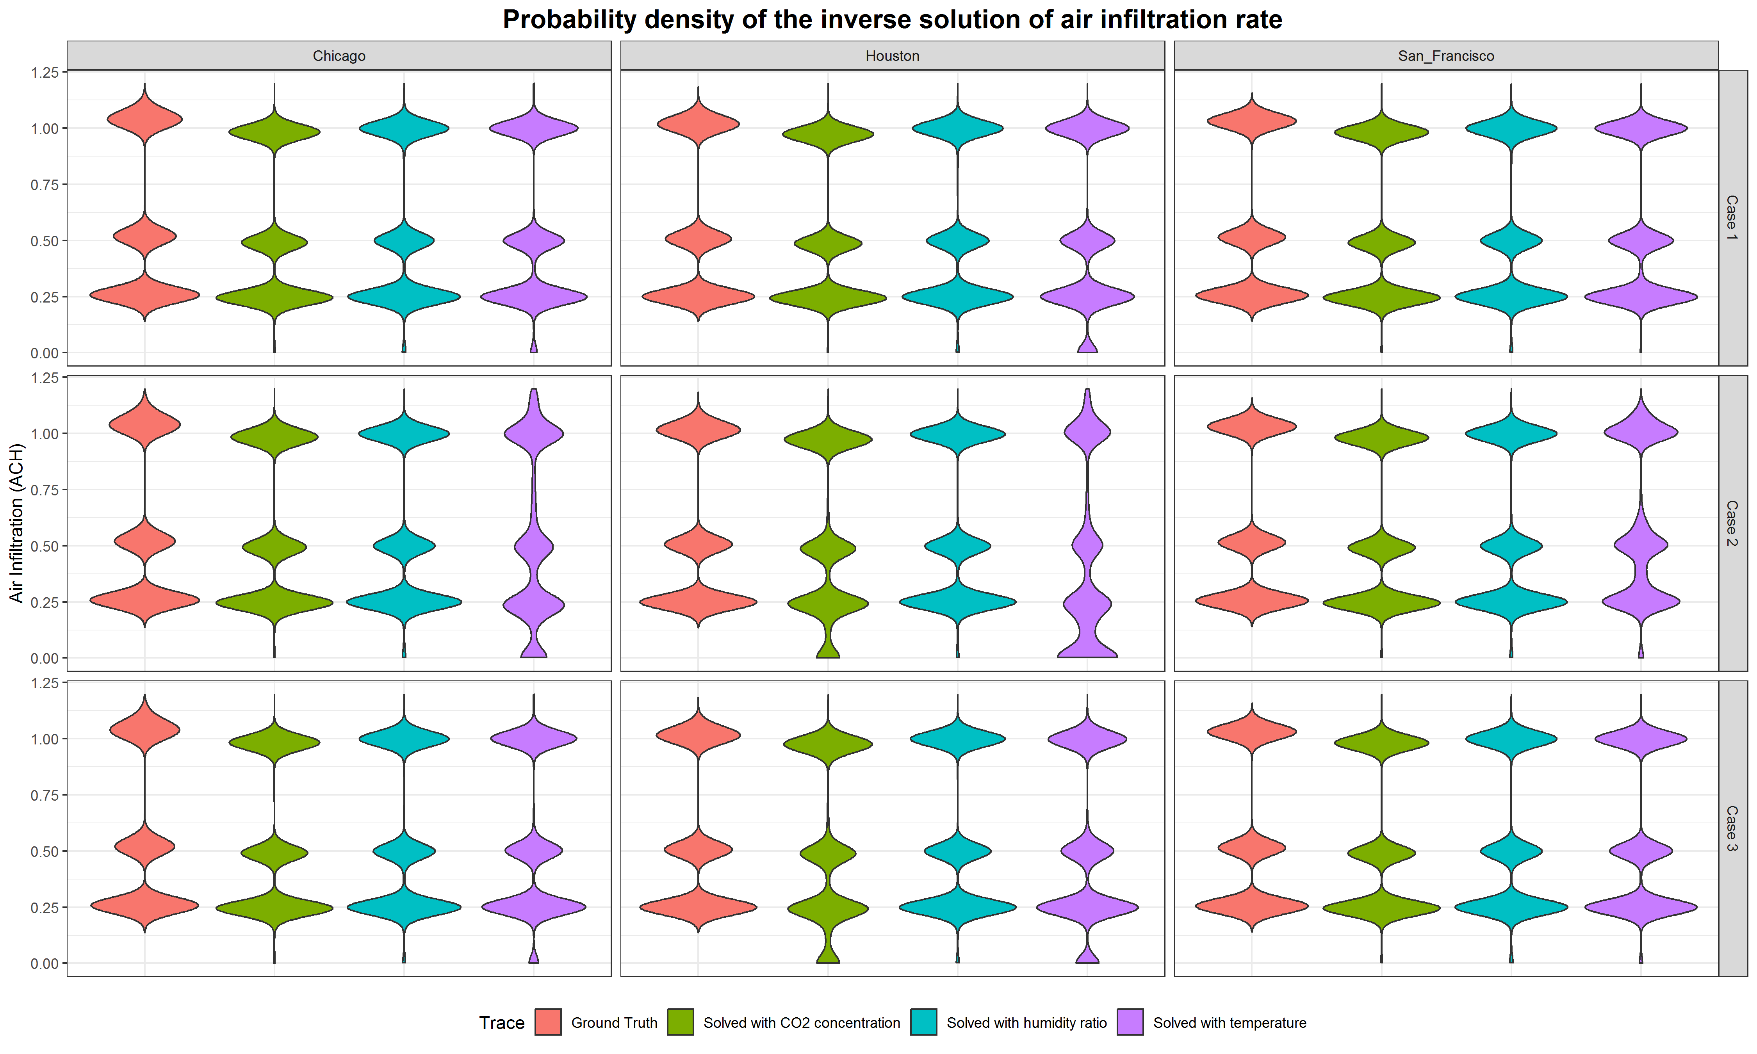

**Figure 11**. Probability density of ground truth and inverse solution of air infiltration

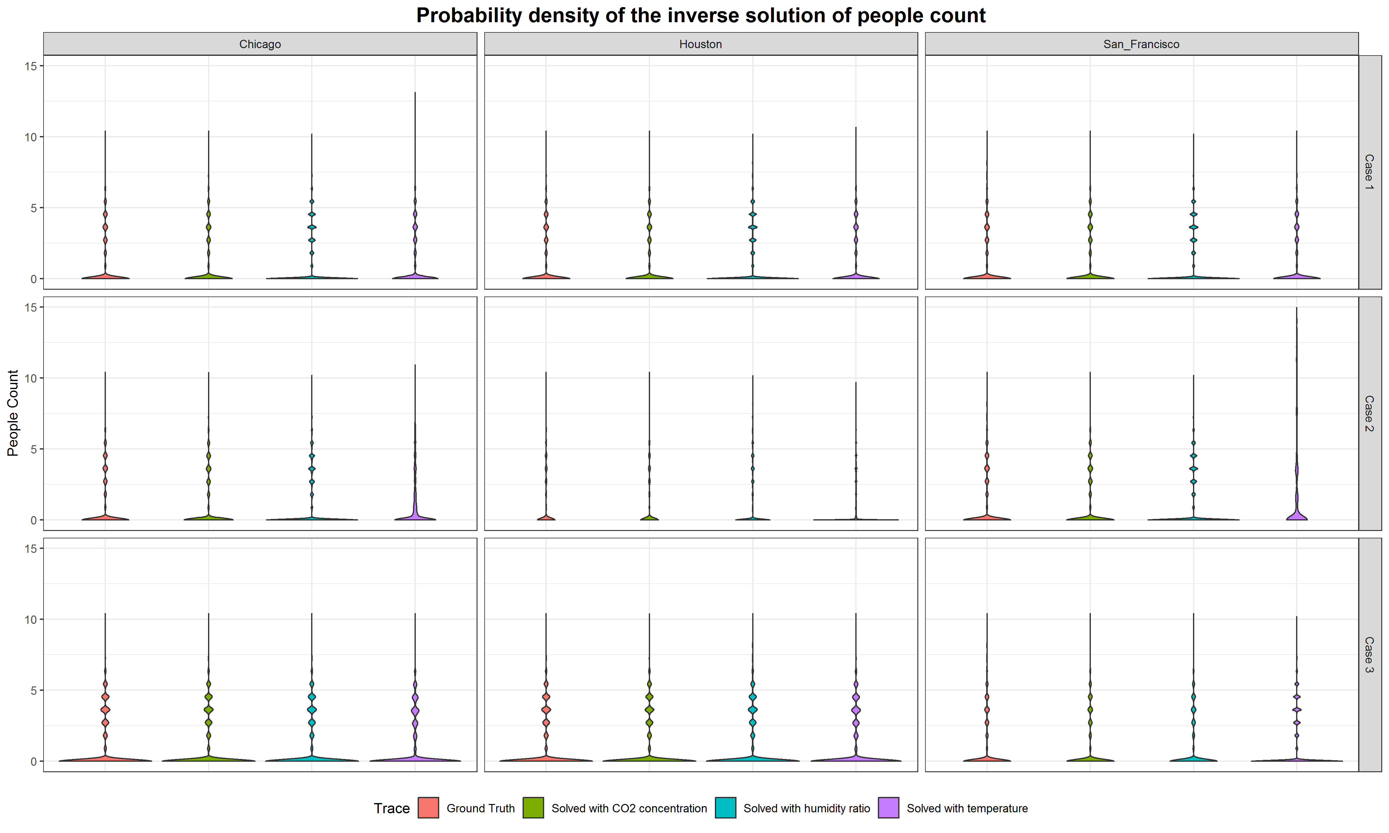

**Figure 12**. Probability density of ground truth and inverse solution of people count

**Table 3**. Performance metrics of the inverse solutions

|  |  |  |  |  |  |  |  |  |  |  |  |  |  |  |  |
| --- | --- | --- | --- | --- | --- | --- | --- | --- | --- | --- | --- | --- | --- | --- | --- |
| **Location** | | | | Chicago | | | | Houston | | | | San Francisco | | | |
| Zone | | | | Zone 1 | Zone 2 | Zone 3 | Zone 4 | Zone 1 | Zone 2 | Zone 3 | Zone 4 | Zone 1 | Zone 2 | Zone 3 | Zone 4 |
| **Use case** | **Measured Parameter(s)** | **HVAC Status** | **HVAC model** | **CV(RSMD) of air infiltration solution** | | | | | | | | | | | |
| Case 1 | S1 | Off | No | 0.09 | 0.09 | 0.08 | 0.07 | 0.17 | 0.16 | 0.15 | 0.14 | 0.06 | 0.07 | 0.05 | 0.05 |
| S2 | Off | No | 0.37 | 0.38 | 0.25 | 0.26 | 0.35 | 0.35 | 0.21 | 0.23 | 0.38 | 0.41 | 0.22 | 0.2 |
| S3 | Off | No | 0.14 | 0.18 | 0.21 | 0.23 | 0.12 | 0.11 | 0.18 | 0.21 | 0.13 | 0.14 | 0.19 | 0.22 |
| Case 2 | S4 | On | No | 0.3 | 0.29 | 0.3 | 0.29 | 0.43 | 0.42 | 0.43 | 0.41 | 0.13 | 0.12 | 0.13 | 0.12 |
| S5 | On | No | 0.21 | 0.22 | 0.17 | 0.15 | 0.19 | 0.17 | 0.17 | 0.15 | 0.27 | 0.29 | 0.18 | 0.18 |
| S6 | On | No | 0.16 | 0.2 | 0.17 | 0.18 | 0.19 | 0.17 | 0.26 | 0.29 | 0.16 | 0.18 | 0.18 | 0.19 |
| Case 3 | S7 | On | yes | 0.19 | 0.21 | 0.19 | 0.2 | 0.3 | 0.31 | 0.3 | 0.31 | 0.08 | 0.08 | 0.07 | 0.07 |
| S8 | On | yes | 0.2 | 0.21 | 0.17 | 0.15 | 0.18 | 0.18 | 0.16 | 0.16 | 0.25 | 0.28 | 0.19 | 0.19 |
| S9 | On | yes | 0.16 | 0.19 | 0.17 | 0.17 | 0.19 | 0.16 | 0.26 | 0.29 | 0.16 | 0.18 | 0.18 | 0.19 |
| **Use case** | **Measured Parameter(s)** | **HVAC Status** | **HVAC model** | **CV(RSMD) of people count solution** | | | | | | | | | | | |
| Case 1 | S1 | Off | No | 0.63 | 0.45 | 0.38 | 0.23 | 0.57 | 0.44 | 0.3 | 0.19 | 0.58 | 0.44 | 0.3 | 0.18 |
| S2 | Off | No | 0.67 | 0.6 | 0.23 | 0.21 | 0.72 | 0.64 | 0.24 | 0.21 | 0.62 | 0.54 | 0.19 | 0.16 |
| S3 | Off | No | 0.27 | 0.27 | 0.14 | 0.14 | 0.26 | 0.26 | 0.12 | 0.11 | 0.22 | 0.22 | 0.1 | 0.1 |
| Case 2 | S4 | On | No | 1.2 | 0.68 | 0.99 | 0.54 | 1.29 | 0.75 | 0.92 | 0.54 | 3.98 | 3.52 | 2.92 | 1.9 |
| S5 | On | No | 0.98 | 0.87 | 0.24 | 0.23 | 0.98 | 0.86 | 0.23 | 0.21 | 0.81 | 0.75 | 0.19 | 0.18 |
| S6 | On | No | 0.11 | 0.11 | 0.06 | 0.06 | 0.22 | 0.22 | 0.1 | 0.09 | 0.15 | 0.14 | 0.05 | 0.05 |
| Case 3 | S7 | On | yes | 0.44 | 0.3 | 0.35 | 0.21 | 0.43 | 0.3 | 0.31 | 0.19 | 0.67 | 0.6 | 0.23 | 0.21 |
| S8 | On | yes | 0.39 | 0.36 | 0.1 | 0.1 | 0.48 | 0.4 | 0.13 | 0.12 | 0.54 | 0.51 | 0.11 | 0.11 |
| S9 | On | yes | 0.1 | 0.1 | 0.06 | 0.06 | 0.22 | 0.22 | 0.1 | 0.09 | 0.15 | 0.14 | 0.05 | 0.05 |

1. **Discussion**
2. **Conclusion**

This study develops a new inverse modeling method to solve hard-to-measure building parameters such as air infiltration and people count. The method uses physics-based approach which take advantage of building energy simulations.

Different types of measurements and model assumptions are needed in the inverse modeling process.

The results show that the method can effectively solve the unknown parameters with proper inputs and model assumptions.

Limitations.

Future work use more than one measured parameters to simultaneously solve multiple unknown parameters.

**Acknowledgement**

**Reference**